The process route of aqueous phased method

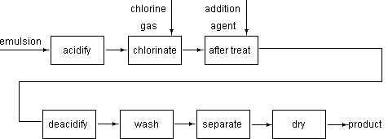

Owner’s information:
Anhui Research Institute of Chemical Industry (ARICI)
Add: 363, Buyan north road, Hefei, China
P.C.: 230041
Tel: 0086-551-5527899
Fax: 0086-551-5524269
Foreign trade depart: 0086-86551-5852528
Fax: 0086-86551-5852528
URL: www.ahrici.com
www.ahrici.com.cn
www.ahrici.cn
E-mail: whykyc@mail.hf.ah.cn

